# 1) INTRUDUCTION

1.1 Overview

Administrator should be able to create all base data including Semester, Candidate, Course and Lecturer, Lecturer should have the ability to create Internal Results, Dean, who, is one of the lecturer, should be the only one with ability to update Internal Results, Re-evaluation Can be initialized by Candidate for all Internal Results.

1.2 Purpose

Implementing a CRM system is a value-adding process that can bring great benefits to any business. The ultimate goal is to improve communication and interaction with real customers and leads, and to maximise their impact on the production process and business figures.

# 2.Problem Definition & Design Thinking

2.1 Empathy Map

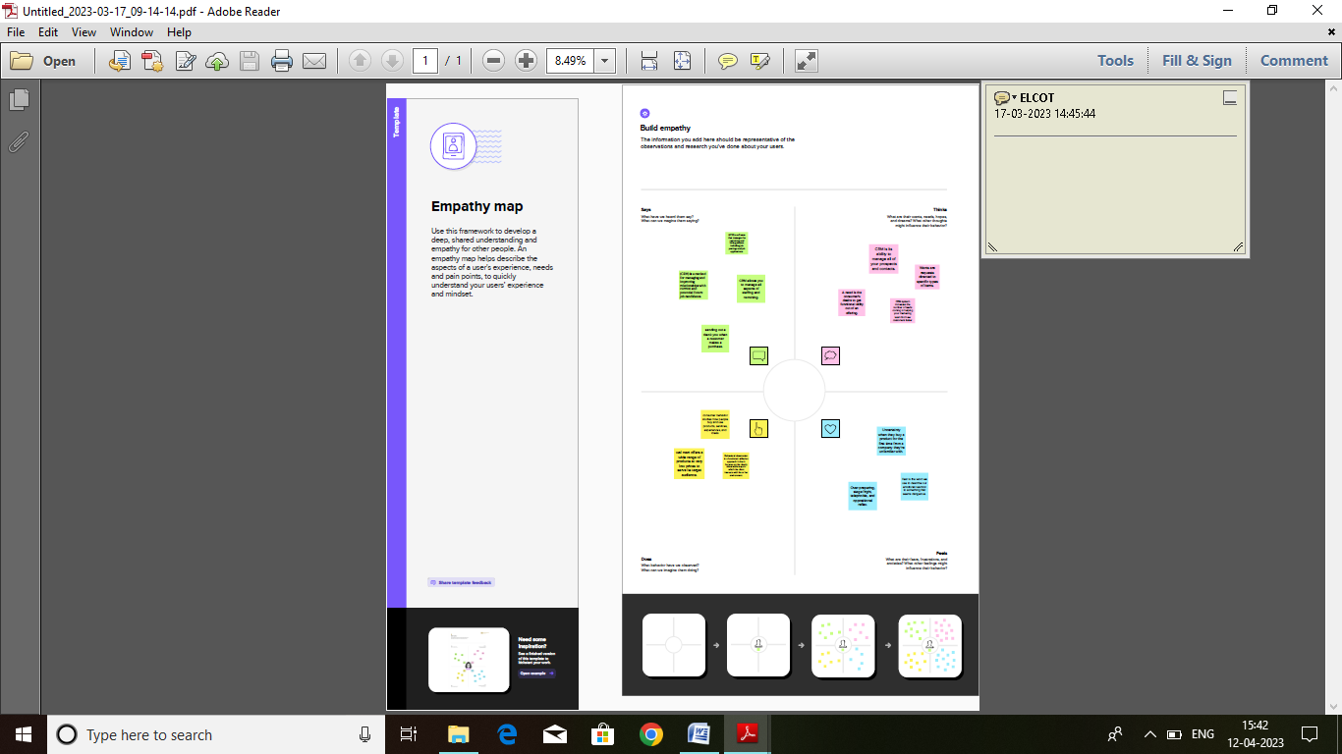

2.2 Ideation & Brainstorming Map

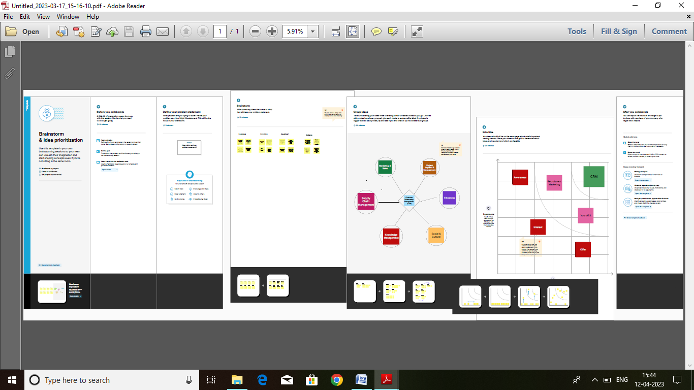

# Result

3.1 Data Model:

|  |  |  |  |  |
| --- | --- | --- | --- | --- |
| Object name | Fields in the Object   |  |  | | --- | --- | | Field label | Data type | | |
| Semester | Student | Students |
| Candidate | Internal Result Card | Internal Result Card |
| Course Details | Course Name | Course Id |

3.2 Activity & Screenshot

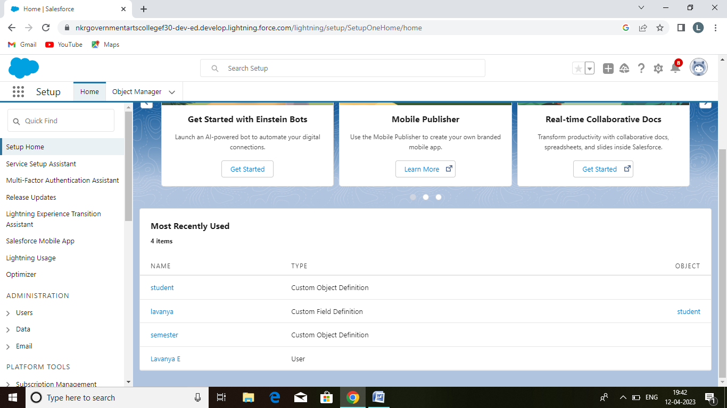

# 4. Trailhead Profile Public URL

Team Lead

Lavanya E : <https://trailblazer.me/id/lavu2>

Team Members

Kiruthika S : <https://trailblazer.me/id/kiruthi2>

Lekhasri A : <https://trailblazer.me/id/llekhasri>

Manju M : <https://trailblazer.me/id/manj2>

# 5. Advantages

Having huge amounts of data on customer interactions enables an organisation to build up a clearer picture of its customers.

The CRM system, the most profitable customers can be identified, with the view to more time being spent targeting them.

The CRM software also lets a business tailor its marketing communications to achieve more effective results and hence, a greater return on investment in sales and marketing.

# Disadvantages

If staff come to rely too heavily on CRM software,it reduces their flexibility in dealing with customer queries.

This has obvious implications for the customer experience and clients may become frustrated, taking their business to a competitor.

They often become helpless in the face of questions from clients where the information isn’t on the system and which requires lateral thinking to solve the problem.

# 6. Applications

Candidate relationship management (CRM) systems are designed to help organize internal and external candidates and engage them over time with relevant updates.

Today the half-life of a learned skill is five years, even shorter for technical skills. In perspective, college degree ‘’book learning’’ can be obsolete within a year of graduation. The most useful talent communities are forward-looking.

What your industry’s technologies evolve rapidly consider sourcing from vocational, certification, and apprenticeship environments for of-the-minute skills.

# 7. Conculsion

CRM in retail allows businesses to make smarter decisions to better serve their customers and maximize profits from repeat purchases.

# 8. Future scope

Customers will become a company’s best sales reps through superior products and services as well as customer-oriented messaging.

The future of CRM is more than just the future of customer Relationship Management software. It is really the future of business.